1. **Bảng Users**

create table Users(

ID int identity (1,1) not null primary key,

Email nvarchar(MAX) not null,

UserDisplayName nvarchar(50) not null,

AboutMe text,

Views int not null,

TopicCounts int not null,

Password varchar(50) not null,

CreationDate date not null,

Role int not null

)

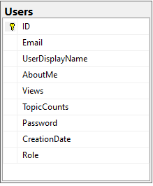

1. **Tạo bảng Skills**

create table Skills(

ID int identity (1,1) not null primary key,

NameSkill nvarchar(255) not null,

LevelSkill int not null,

UserID int not null

CONSTRAINT fk_skill_user

FOREIGN KEY (UserID)

REFERENCES dbo.Users(ID)

)

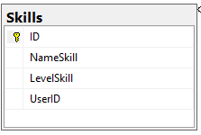

1. **Tạo bảng Profile**

create table Profile(

ID int identity (1,1) not null primary key,

LastName nvarchar(255) not null,

FirstName nvarchar(255) not null,

DateofBirth date not null,

ImgUrl varchar(255) not null,

Gender varchar(225) not null,

Adresss nvarchar(MAX) not null,

UserID int not null

CONSTRAINT fk_profile_user

FOREIGN KEY (UserID)

REFERENCES dbo.Users(ID)

)

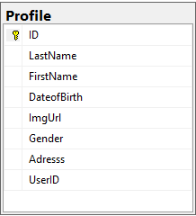

1. **Tạo bảng Topics**

create table Topics(

ID int identity (1,1) not null primary key,

Tags nvarchar(255) not null,

CommentCount int not null,

Body text not null,

CreationDate date not null,

Title text not null,

UserID int not null,

CONSTRAINT fk_topic_user

FOREIGN KEY (UserID)

REFERENCES dbo.Users(ID)

)

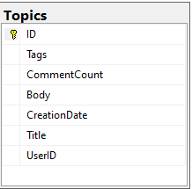

1. **Tạo bảng Comments**

create table Comments(

ID int identity (1,1) not null primary key,

Body text not null,

CreationDate date not null,

UserID int not null,

CONSTRAINT fk_comment_user

FOREIGN KEY (UserID)

REFERENCES dbo.Users(ID),

TopicID int not null,

CONSTRAINT fk_comment_topic

FOREIGN KEY (TopicID)

REFERENCES dbo.Topics(ID)

)

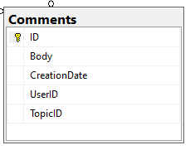

1. **Tạo bảng ReactTypes**

create table ReactTypes(

ID int identity(1,1) not null primary key,

Name nvarchar(255) not null,

ImgUrlReact varchar(MAX) not null

)

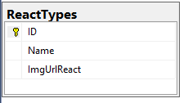

1. **Tạo bảng Reacts**

create table React(

ID int identity(1,1) not null primary key,

CountReacts int not null,

ReactTypeID int not null,

UserID int not null,

TopicID int not null,

CONSTRAINT fk_react_user

FOREIGN KEY (UserID)

REFERENCES dbo.Users(ID),

CONSTRAINT fk_react_reactType

FOREIGN KEY (ReactTypeID)

REFERENCES dbo.ReactTypes(ID),

CONSTRAINT fk_react_topic

FOREIGN KEY (TopicID)

REFERENCES dbo.Topics(ID),

)

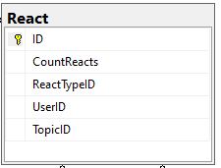

1. **Tạo bảng Imgs**

create table Imgs(

ID int identity(1,1) not null primary key,

ImgUrl varchar(MAX) not null,

TopicID int not null,

CONSTRAINT fk_img_topic

FOREIGN KEY (TopicID)

REFERENCES dbo.Topics(ID),

)

